HACKATHON PROJECT DOCUMENTATION

***TOPIC- Identify New Bikes***

|  |  |
| --- | --- |
| **TEAM MEMBERS** | |
| **NAME** | **EMPLOYEE ID** |
| **JENIL JUIN DJ** | **2151265** |
| **KAVIN BHARATHI TK** | **2151155** |
| **KISHORE METTUKADAI THIYAGARAJAN** | **2150963** |
| **NITHYA NIRANJAN TP** | **2151163** |
| **SRIDHAR S** | **2151271** |

# WEBSITE:

<https://www.zigwheels.com/>

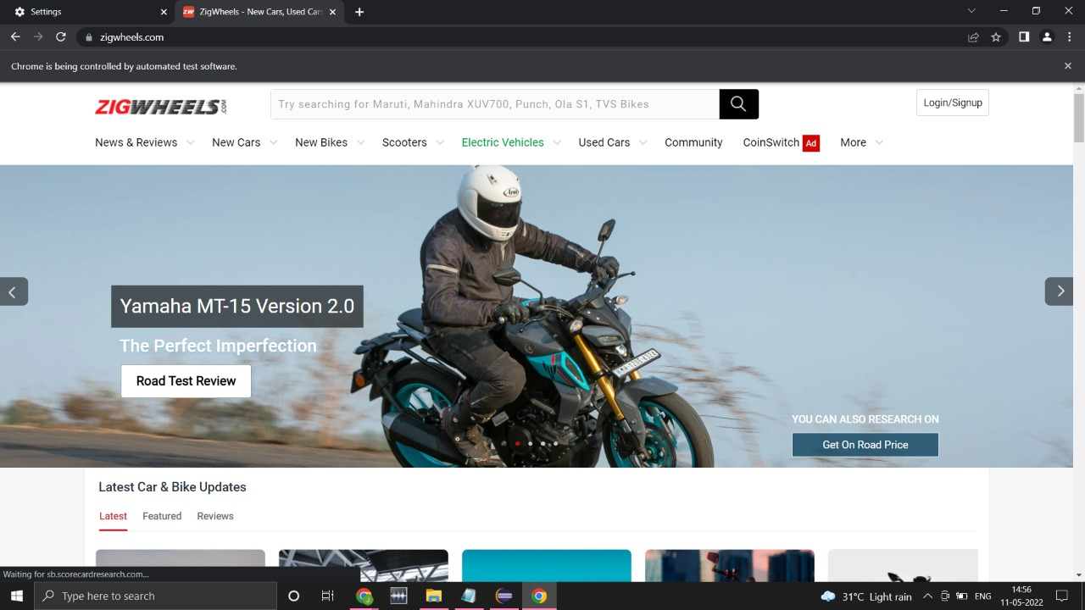

# TOOLS & TECHNOLOGY USED:

* 1. ***Selenium with Java in Eclipse***: Selenium is a portable framework for testing web applications. Selenium provides a playback tool for authoring functional tests. Developed using Java, the Eclipse platform can be used to develop rich client applications, integrated development environments and other tools. Eclipse can be used as an IDE for any programming language for which a plug-in is available***.***
  2. ***TestNG***: TestNG (Test Next Generation) is the testing framework. TestNG is inspired from JUnit and NUnit, but it has a new functionality that makes this framework more powerful and easier. TestNG is designed in such a way that it covers all the categories of tests comprising unit, functional and integration.
  3. ***Maven***: Maven is a build automation tool used primarily for Java projects. Maven can also be used to build and manage projects written in C#, Ruby, Scala, and other languages. Maven is built using a plugin- based architecture that allows it to make use of any application controllable through standard input.
  4. ***POM with POI***: Page Object Model (POM) is a design pattern, popularly used in test automation that creates Object Repository for web UI elements. The advantage of the model is that it reduces code duplication and improves test maintenance. Under this model, for each web page in the application, there should be a corresponding Page Class. This Page class will identify the WebElements of that web page and also contains Page methods which perform operations on those WebElements. Apache POI, a project run by the Apache Software Foundation, and previously a sub-project of the Jakarta Project, provides pure Java libraries for reading and writing files in Microsoft Office formats, such as Word, PowerPoint and Excel.

# WORD DONE:

* 1. The Code is written in JAVA and is automated in different browsers with the help of Selenium. The project and dependencies are managed with the help of Maven.
  2. POM is used to create classes for each page therefore reducing usage of same code for various objects.
  3. Input data is obtained from properties file and from excel sheet with the help of Apache POI.

# REQUIREMENTS AND EXECUTION STEPS:

## Display "Upcoming" bikes details like bike name, price and expected launch date in India, for manufacturer 'Honda' & Bike price should be less than 4Lac.

* + - Display new bikes from Honda manufacturer
    - Search in search bar
    - Display upcoming bikes under 4lacs and also under 2 lacs by storing them in array and writing in excel sheet

## For Used cars in Chennai, extract all the popular models in a List; Display the same.

* Go to Used cars drop down and select the following cities: Chennai
* Extract the displayed options and write them in excel sheet

## Try to 'Login' with google, give invalid account details & capture the error message

* + - Click on Login button in Homepage
    - Login to google with invalid credentials and capture screenshot

# SCREENSHOTS

* **Upcoming Bikes in India**

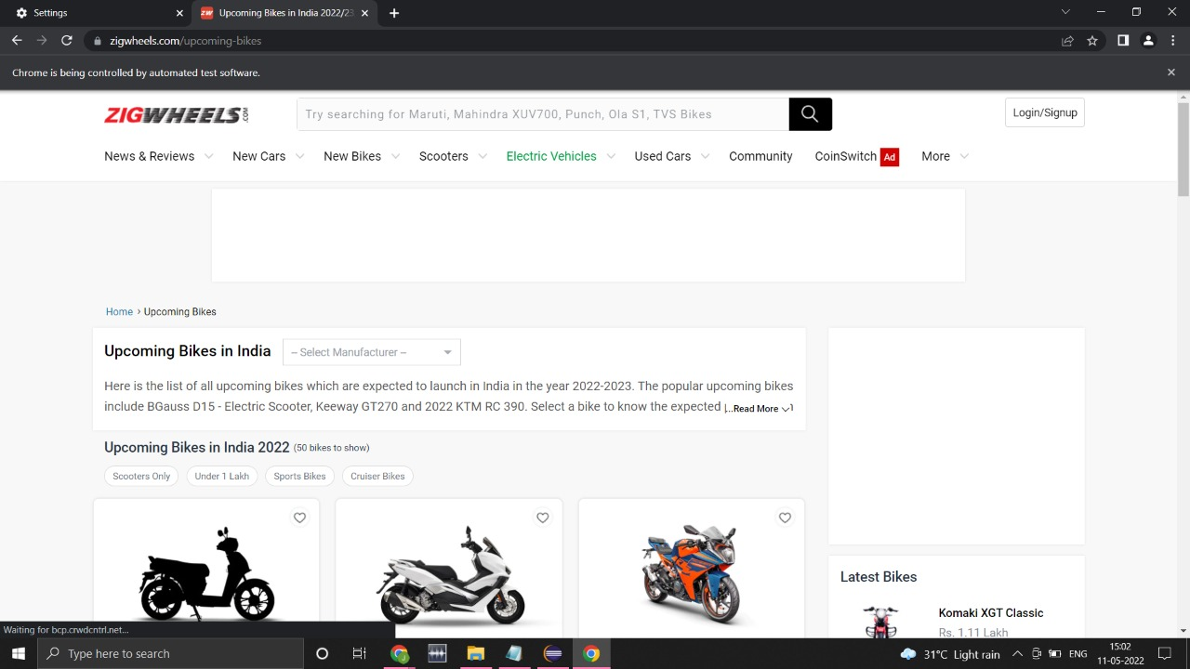

* **Honda Upcoming Bikes in India**

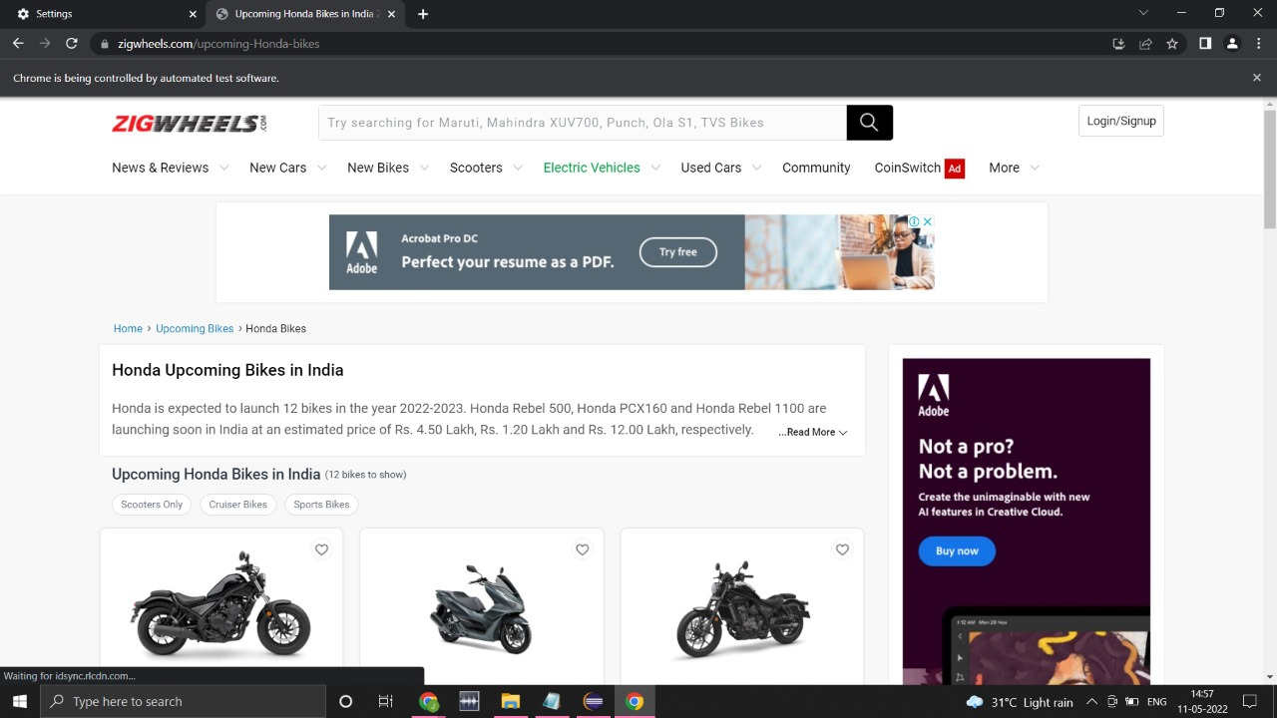

* **Used Cars in Chennai**

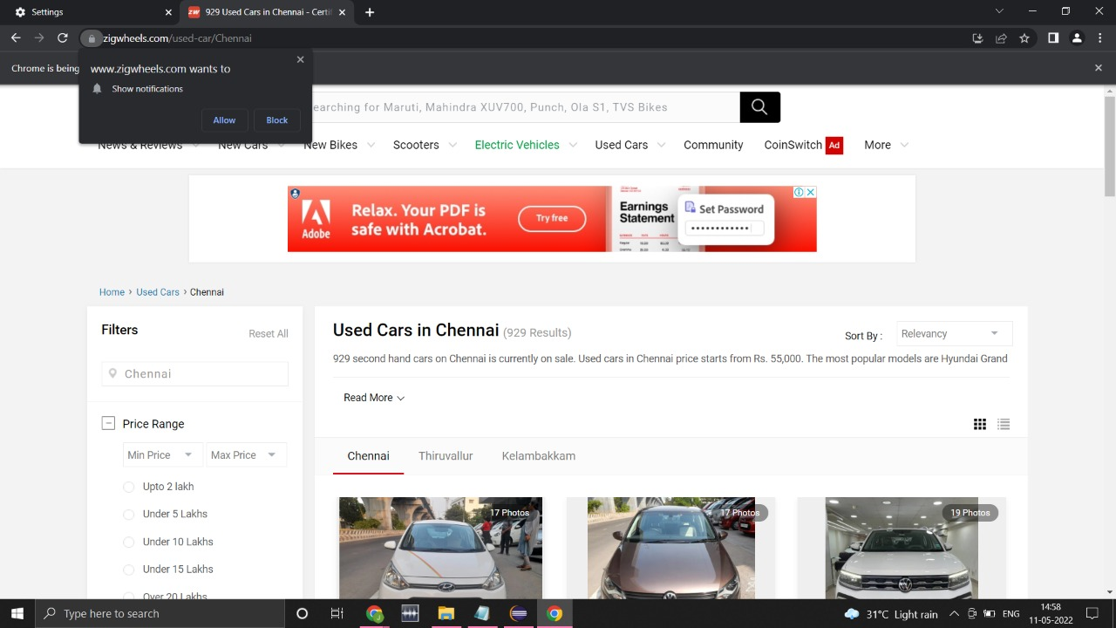

* **Login with Invalid email and shows error message**

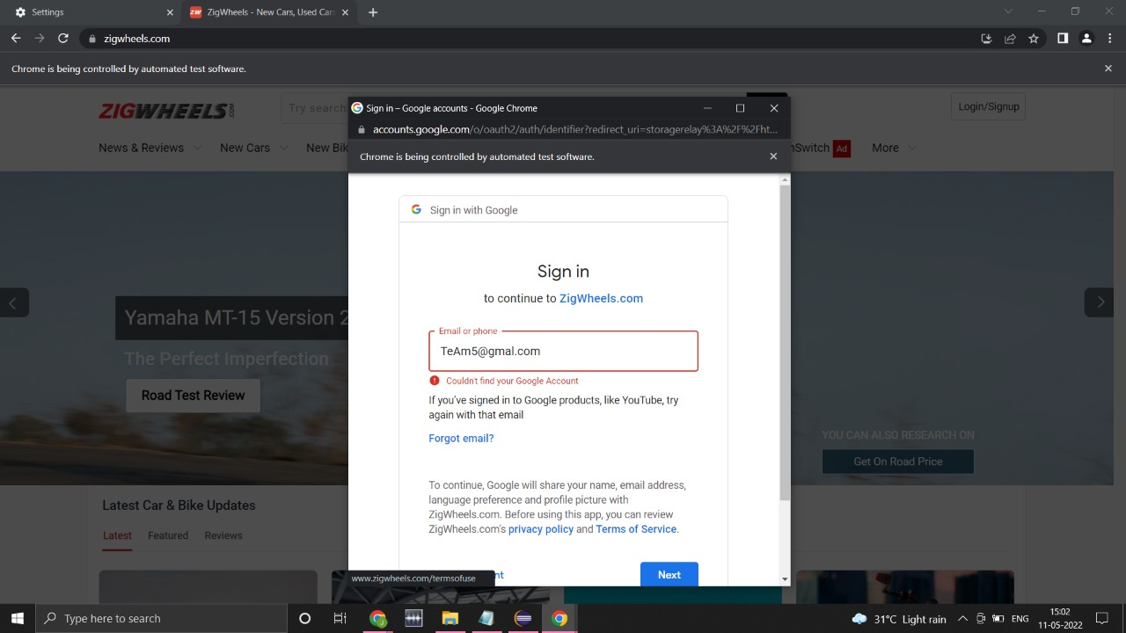

* Test Case Passed

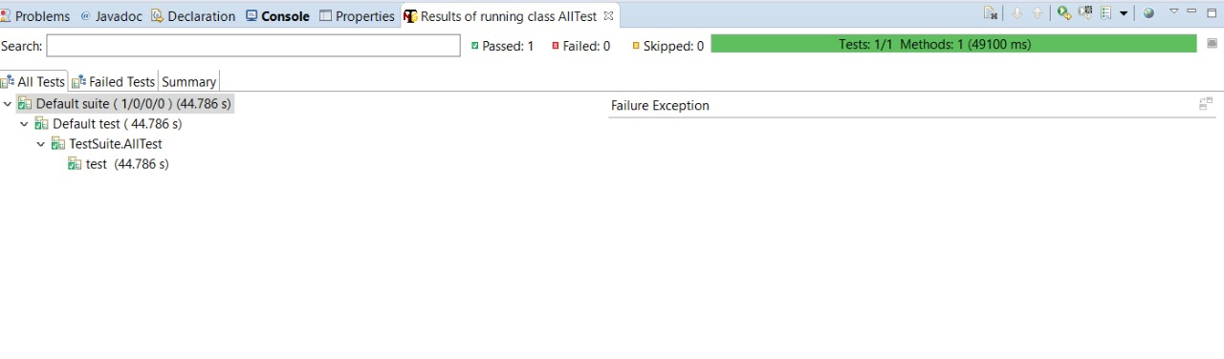

* **Console (Output)**

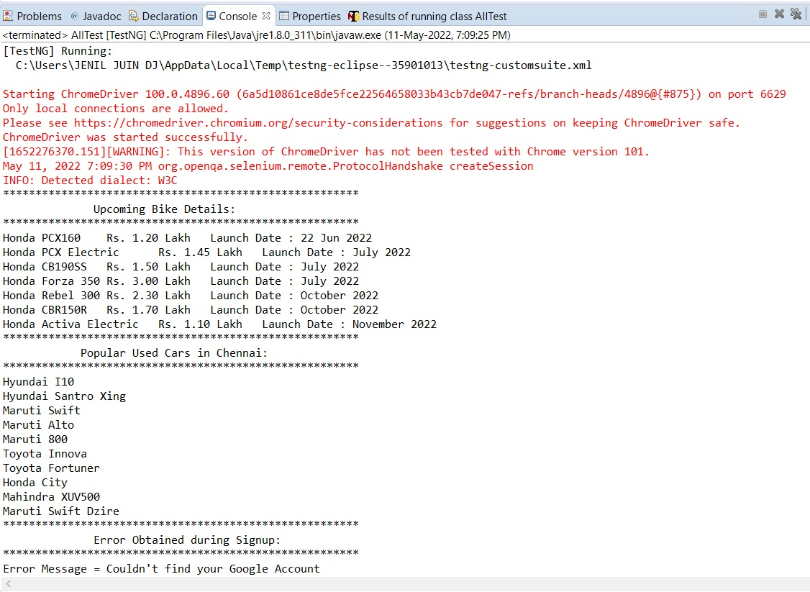

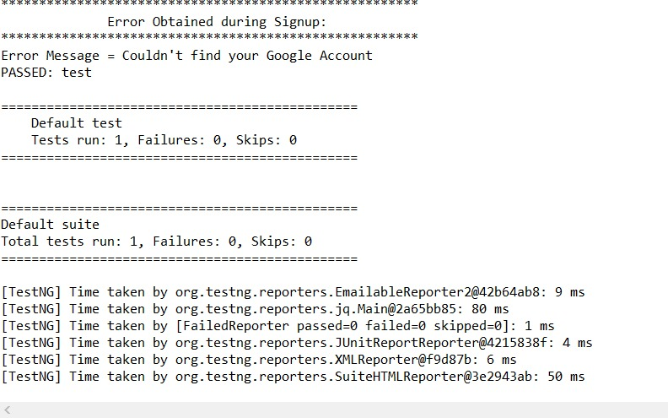

**Thank you**